Government of Pakistan
Ministry of Interior
<><><>
No.7/16/2015/16 (G&P) Islamabad, the 10th April, 2017
OFFICE MEMORANDUM
Subject: - UPLOADING OF TENDER NOTICE ON PPRAs WEB SITE
The undersigned is directed to enclose herewith tender notice regarding supply of Machinery, Computer Equipments, and Furniture/Fixture items. It is requested that said tender notice may please be uploaded on PPRAs web site before publication in the press.
2. It is requested that aid tender notice may be up-loaded on the
PPRAs web site at the earliest please. | 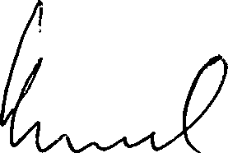
(Shadab Ahmed) Section Officer (G&P) Tele: 9202608
Public Procurement Regulatory Authority
(Mr. Jamil Ahmed Rathore)
Deputy Director (M&MO)
Government of Pakistan
Islamabad.

